ERC-RAG: An Energy-based Retrieval Clustering for RAG in Vietnamese Economy Chatbots
Anh-Khoi Ngo-Ho^{1 [0000-0001-5444-5927]}, Chi-Nghia Ngo¹ and Anh-Khoa Ngo-Ho^{1 [0000-0002-4844-5012]}
¹ Faculty of Information Technology, Nam Can Tho University, 168 Nguyen Van Cu Street, An Binh Ward, Can Tho City, Vietnam.
{nhakhoi@nctu.edu.vn; nhakhoa@nctu.edu.vn; nghia220321@student.nctu.edu.vn}
Abstract. Retrieval-Augmented Generation (RAG) has emerged as an effective framework for enhancing the factual grounding and reliability of large language model-based chatbots, particularly in domain-specific question answering. However, most existing RAG systems rely on cosine similarity over dense embeddings for document retrieval, which provides only a linear approximation of semantic compatibility and may be inadequate for nuanced domains such as economic question answering. In this paper, we propose the Energy-based Retrieval Clustering RAG (ERC-RAG) framework for Vietnamese economy chatbots. The proposed approach first decomposes the user query into multiple sub-queries using a large language model to form a query distribution, applies cosine similarity across all sub-queries as a lightweight candidate retrieval mechanism, and subsequently employs energy distance between the query distribution and each KMeans document cluster to select the most relevant cluster for generation. We evaluate the framework on the Vietnamese Economy Information Database using the VNEIQAD benchmark. Experimental results show that ERC-RAG improves retrieval performance over conventional RAG variants, yielding more focused and numerically accurate responses. Our findings provide empirical evidence that energy distance between query and document distributions is a promising approach for cluster-level retrieval in domain-specific RAG systems, particularly in low-resource languages such as Vietnamese.
Keywords: automatic question answering, chatbot, Vietnamese language, generative AI, retrieval-augmented generation, energy-based models, energy distance, KMeans clustering, query decomposition, retrieval clustering.
- Introduction
Chatbots are software systems designed to simulate human conversation through text- or voice-based interaction. They have been applied to a wide range of specialized domains, including knowledge-graph-based natural language understanding (Ait-Mlouk & Jiang, 2020) and intelligent medical consultation (Ni et al., 2024). In recent years, most high-performing chatbots have been built upon large language models (LLMs), which enable fluent, context-aware, and coherent response generation. LLM-based question answering systems can be adapted to specific domains through prompt engineering, fine-tuning, or external knowledge integration, thereby improving their applicability in real-world scenarios. As LLMs are increasingly deployed in specialized domains, ensuring factual correctness and domain consistency has become a critical research challenge. Retrieval-Augmented Generation (RAG) has emerged as a widely adopted solution to improve the reliability and factual grounding of LLM-based systems. Instead of relying solely on parametric knowledge encoded in model weights, RAG retrieves relevant documents from an external knowledge source and conditions the generation process on the retrieved context. This paradigm has been shown to reduce hallucination, improve answer correctness, and enable knowledge updates without retraining the underlying language model. Recent studies have demonstrated the effectiveness of RAG for Vietnamese chatbot applications, particularly in domain-specific question answering tasks (Ngo-Ho et al., 2024a; Ngo-Ho et al., 2024b), highlighting its potential for low-resource languages and specialized domains.
Within document-based RAG systems, numerous techniques have been proposed to improve retrieval quality, including maximal marginal relevance for balancing relevance and diversity (Ye et al., 2023), multi-query generation and fusion strategies (Rackauckas et al., 2024), and hybrid retrieval mechanisms that integrate dense vector search with sparse keyword-based methods such as BM25 (Chen et al., 2023; Sawarkar et al., 2024). Despite these advances, most contemporary RAG retrievers continue to rely on cosine similarity over dense embeddings as the primary relevance scoring function. While computationally efficient, cosine similarity assumes a linear geometric relationship between embeddings and may inadequately capture complex or task-specific query-document compatibility, particularly in domains that require precise numerical and factual alignment, such as economic question answering.
This limitation is especially pronounced in Vietnamese economy chatbots, where small semantic mismatches or loosely related contextual passages can lead to incorrect numerical interpretations or misleading conclusions. These observations motivate the exploration of alternative relevance modeling approaches that go beyond linear similarity measures while remaining compatible with practical RAG pipelines.
In this paper, we propose the Energy-based Retrieval Clustering RAG (ERC-RAG) framework tailored for Vietnamese economy chatbots. The proposed approach employs a three-stage architecture: a large language model first decomposes the original query into multiple semantically distinct sub-queries, forming a query distribution; cosine similarity is then applied across all sub-queries to efficiently retrieve a pool of candidate documents; and finally, energy distance between the query distribution and each KMeans document cluster is computed to select the most semantically compatible cluster as context for generation. This distribution-level formulation enables a richer representation of both query intent and document relevance than single-vector cosine similarity.
We conduct an empirical evaluation on the Vietnamese Economy Information Database (VEID) using the VNEIQAD benchmark. The results demonstrate that ERC-RAG improves retrieval performance compared with widely used RAG baselines. Furthermore, our findings suggest that using energy distance between a query distribution and document cluster distributions constitutes a viable approach for cluster-level retrieval in domain-specific and low-resource RAG settings, particularly for numerically sensitive economic question answering tasks.
- Energy-based concepts in LLMs and RAG
A RAG framework typically includes an information retrieval component, referred to as a retriever, which searches for relevant external knowledge from structured or unstructured sources such as databases, books, academic articles, and web documents. Depending on semantic requirements, the retriever can be implemented using different storage and retrieval mechanisms, including vector databases, graph databases, or conventional SQL databases. In this work, our RAG framework employs a vector database to store economic knowledge, while other retrieval strategies are left for future investigation.
Recent research has also investigated the integration of energy-based models with LLMs to improve retrieval and generation performance. Originally introduced by LeCun et al. (2006), EBMs assign low energy scores to compatible input-output pairs, providing a flexible probabilistic modeling framework without requiring explicit normalization. Training unnormalized energy-based models is facilitated by methods such as noise-contrastive estimation (Gutmann & Hyvärinen, 2010), which estimate model parameters by distinguishing data from noise samples. Recent advancements in artificial intelligence have increasingly explored the integration of energy-based models with LLMs to enhance performance in various domains, particularly in retrieval-augmented generation (RAG) systems. Building on this, Bhattacharyya et al. (2021) introduced energy-based reranking for neural machine translation by training an energy-based model (EBM) to approximate task metrics such as BLEU, assigning lower energy to higher-quality translations and improving outputs through energy minimization over candidate sequences. More recently, the integration of EBMs into retrieval and generation architectures remains limited but promising. Shankar et al. (2025) apply an EBM in a healthcare RAG setting to learn a smooth energy landscape over query-document pairs, assigning low energy to compatible pairs and high energy to incompatible ones. This enables reliable abstention on out-of-distribution queries and improves confidence estimation compared to calibrated softmax and density-based methods. Similarly, Cai et al. (2025) propose Entriever, an energy-based retriever for knowledge-grounded dialogue systems that models candidate retrieval results jointly through an energy function. Their approach outperforms strong cross-encoder baselines, particularly in semi-supervised knowledge retrieval scenarios.
Motivated by the concept of energy as a scalar potential; where desirable configurations correspond to lower energy and mismatched configurations to higher energy; we adopt the energy distance (Rizzo et al., 2016) as a similarity metric in the retrieval stage of RAG. Unlike cosine similarity, which measures angular alignment in embedding space, energy distance can be interpreted as a statistical distance between probability distributions, enabling a more distribution-aware comparison between queries and documents (Kayal et al., 2021).
Collectively, these studies represent early efforts to extend energy-based principles beyond conventional similarity measures in LLM-integrated systems. However, the literature remains sparse, highlighting that the exploration of energy distance for distribution-aware cluster selection within RAG pipelines is still at an early stage. The algorithm proposed in this paper contributes to this emerging line of research by incorporating energy-based cluster scoring into retrieval-augmented generation for domain-specific LLM applications.
- ERC-RAG Framework for Vietnamese Economy Chatbots
In this section, following the works of (Ngo-Ho et al., 2024a; Ngo-Ho et al., 2024b), we delineate the ERC-RAG framework for the Generative Vietnamese Economy Chatbot (GVEC), which augments the conventional RAG pipeline with three key components: LLM-based query decomposition to construct a query distribution, KMeans clustering of candidate documents, and energy distance scoring between the query distribution and each document cluster.
The conventional RAG pipeline begins with embedding the user's query and the documents in a vector database using an embedding model to produce dense representations. Retrieval then identifies relevant documents by computing semantic similarity, typically via cosine similarity, defined as 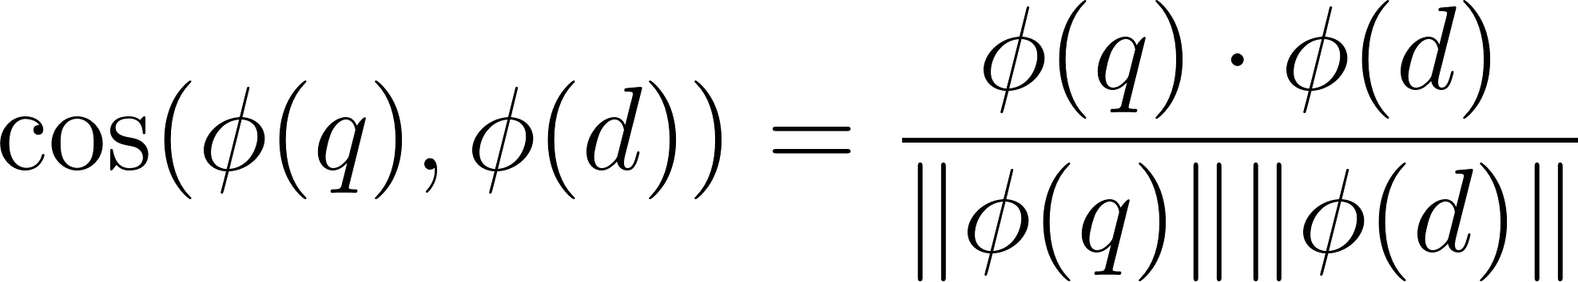, where 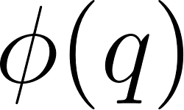 is the query embedding and 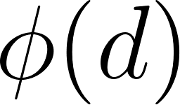 is the document embedding. Documents with the highest cosine scores (closest to 1) are selected as top-k candidates. These retrieved contexts are augmented into a prompt, which is fed to a LLM for generation, ensuring responses are grounded in external knowledge to mitigate hallucinations. This approach, while effective for general semantic alignment, often struggles with nuanced compatibility in domain-specific tasks like economic QA, where subtle contextual mismatches can lead to inaccurate retrievals.
The proposed algorithm is motivated by two key observations. First, in most existing RAG systems, cosine similarity primarily captures geometric proximity in the embedding space and may provide only a limited approximation of the true semantic compatibility between a user query and candidate documents. Second, a single query vector may fail to fully represent the informational intent of complex or multi-faceted questions. To address these limitations without sacrificing efficiency, we adopt a three-stage retrieval architecture that combines LLM-based query decomposition, cosine-based multi-query candidate retrieval, and energy-based cluster selection.
In the first stage, a large language model decomposes the original query into multiple semantically distinct sub-queries, which together form a query distribution. Each sub-query is used to retrieve candidate documents from the vector database via cosine similarity, and the resulting document sets are unified into a single deduplicated candidate pool. This multi-query strategy expands retrieval coverage and ensures that documents relevant to different aspects of the original question are all included in the candidate pool.
In the second stage, the candidate documents are grouped into semantically coherent clusters using KMeans, with the optimal number of clusters automatically determined via the silhouette score. For each cluster, energy distance is computed between the query distribution X (the set of embedded sub-query vectors) and the cluster document distribution Y (the embeddings of documents assigned to that cluster), following the energy distance formulation of Rizzo & Székely (2016). Formally,
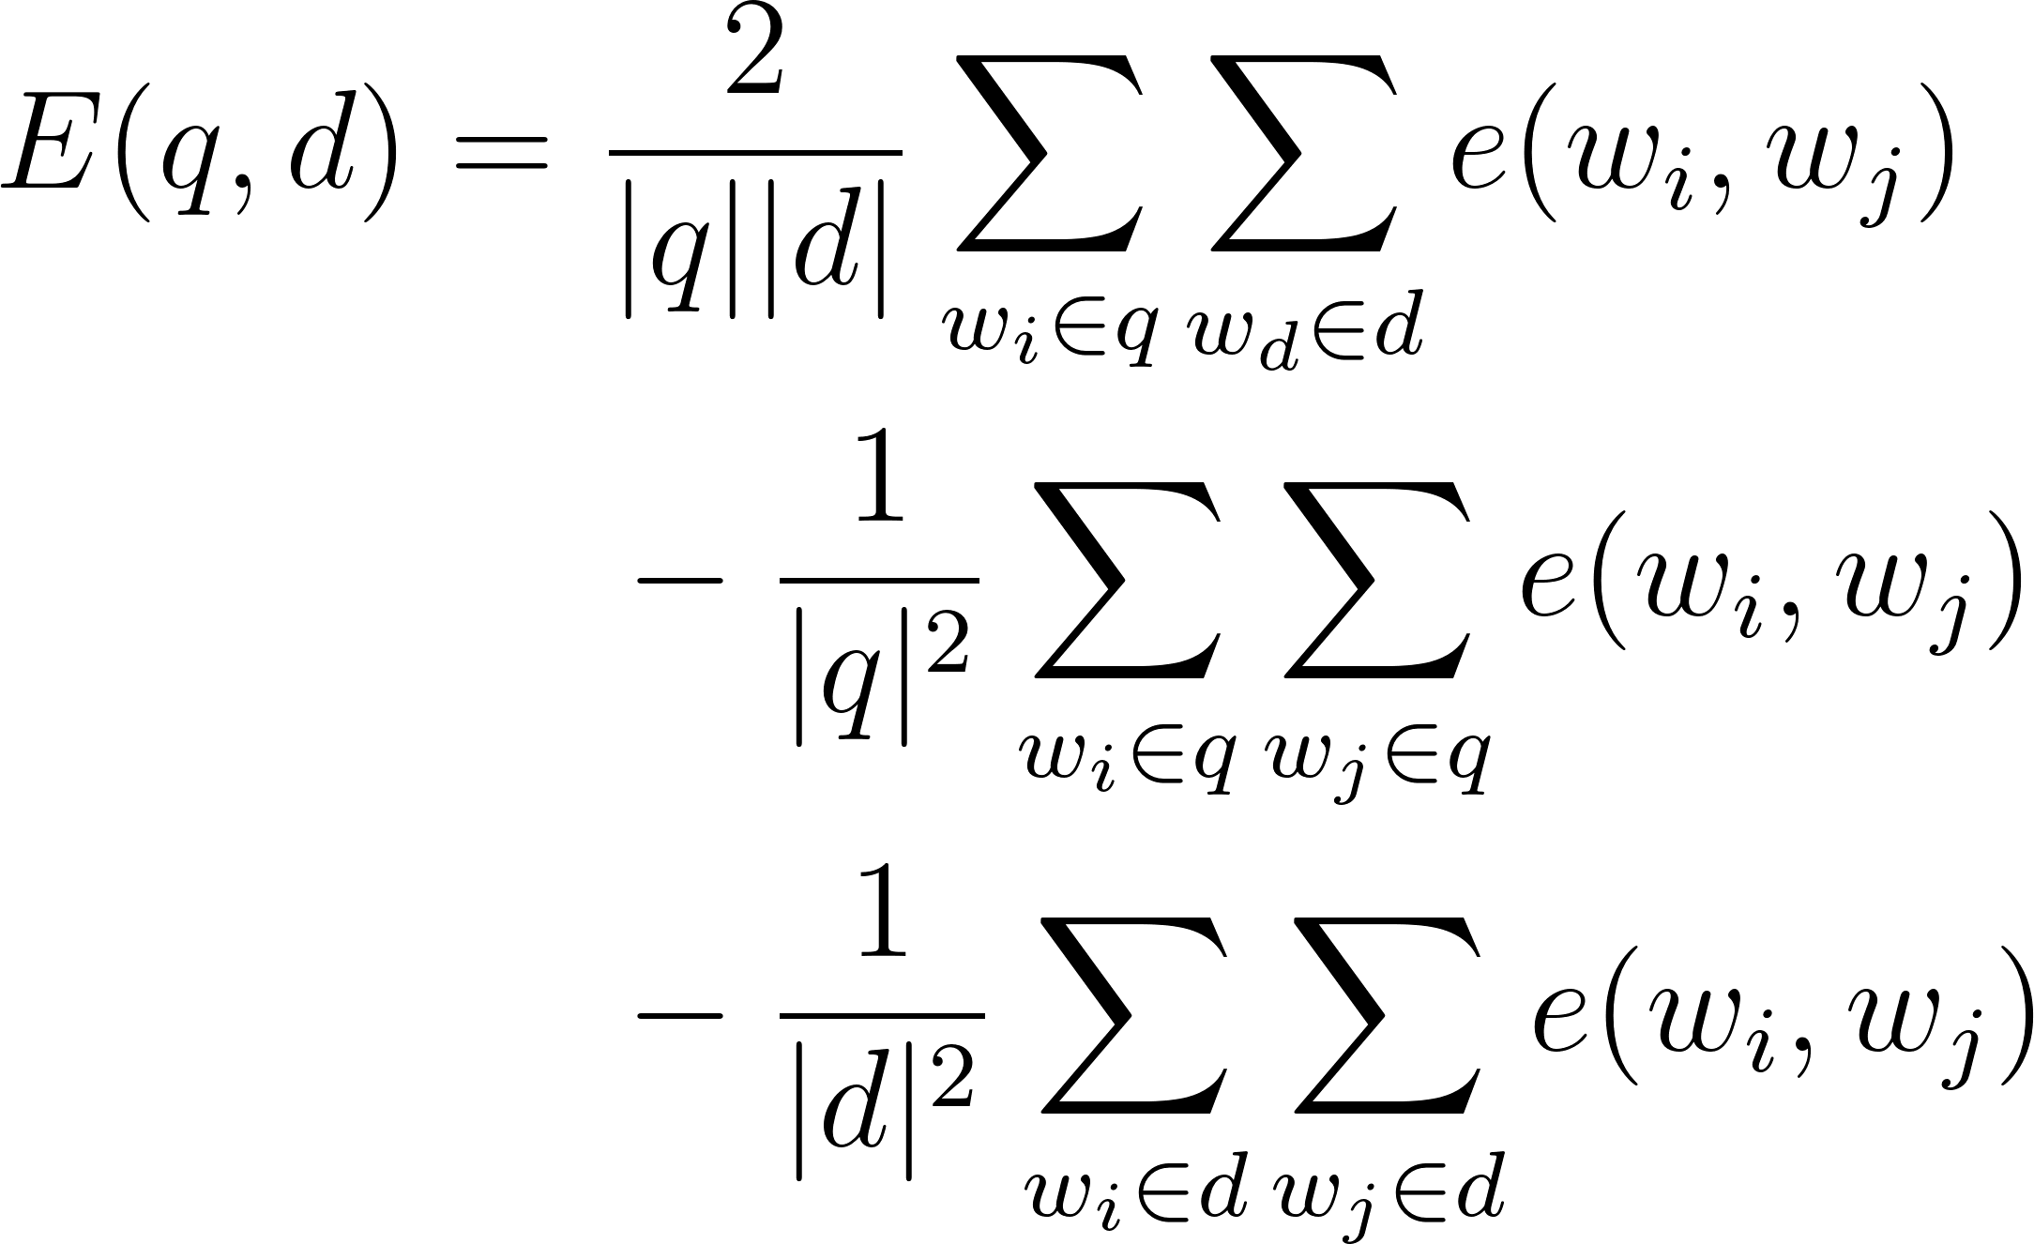
Where the distance 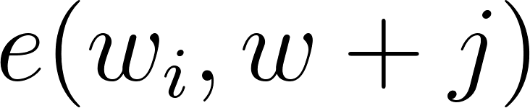 between a query part embedding  and a document embedding  is computed as the Euclidean distance, following Kayal et al. (2021).
The cluster with the minimum energy distance to the query distribution is selected, and the documents within that cluster are passed to an LLM for relevance filtering before being used as context for answer generation. By treating the query as a distribution of multiple vectors rather than a single point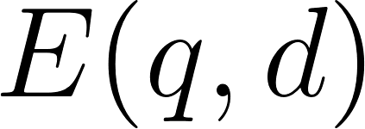, the energy-based scoring captures richer semantic structure and enables more nuanced, distribution-aware cluster selection in the RAG pipeline.
The proposed ERC-RAG framework can be situated within the contemporary retrieval and RAG literature as a distribution-aware, clustering-based retrieval approach that integrates three complementary components: LLM-based query decomposition, KMeans document clustering, and energy-based distribution matching. The use of multi-query decomposition relates to multi-query generation and fusion strategies (Rackauckas et al., 2024), which expand retrieval coverage by issuing multiple queries from a single user question. However, existing multi-query RAG approaches typically aggregate retrieved documents through score fusion rather than distribution-level compatibility scoring. The proposed ERC-RAG approach instead leverages the full set of sub-query embeddings as a query distribution, enabling a richer representation of query intent for downstream cluster scoring.
From a clustering perspective, ERC-RAG is related to clustering-based RAG methods that organize retrieved documents into semantic groups to improve context quality. However, prior clustering-based RAG approaches typically select documents from clusters based on document-level similarity scores or heuristic aggregation. In contrast, ERC-RAG employs energy distance between the query distribution and each document cluster distribution as the cluster selection criterion, treating each cluster as a probability distribution rather than a set of individual documents. This distribution-to-distribution matching aligns with the theoretical foundations of energy distance (Székely & Rizzo, 2013; Rizzo & Székely, 2016) and the k-groups framework (Li & Rizzo, 2017), which generalizes k-means by replacing centroid-based objectives with energy distance formulations over entire distributions.
Therefore, while the overall pipeline shares structural similarities with multi-query RAG and clustering-based retrieval systems, its conceptual novelty lies in the joint use of LLM-generated query distributions and energy distance between distributions for cluster selection. The use of energy distance between a multi-vector query distribution and document cluster distributions as the primary retrieval signal within a RAG framework remains underexplored in the literature, distinguishing ERC-RAG from both conventional neural re-rankers and existing clustering-based RAG approaches.

Algorithm: Energy-based Retrieval Clustering RAG (ERC-RAG)
Input:
Query q
Document collection D
Embedding model f(·)
Pre-retrieval size per sub-query N = 40; LLM for query splitting λ; Maximum sub-queries M = 4
Output: Generated answer r
Step 1: Query Input
The system receives a text query from the user:
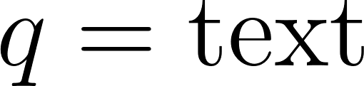
Step 2: LLM Query Splitting and Embedding
The LLM λ decomposes the original query q into M semantically distinct sub-queries {q₁, q₂, ..., qₘ}. Together with the original query q₀ = q, these form the query distribution Q = {q₀, q₁, ..., qₘ}. Each part is embedded using the multilingual E5 embedding model (Wang et al., 2022) to produce the query distribution vectors:
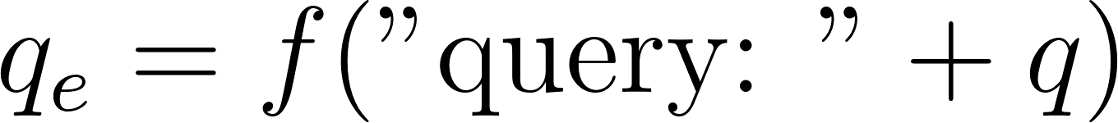
Step 3: Multi-Query Cosine Similarity Retrieval
For each query part 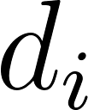 in Q, retrieve the top-N candidate documents from the vector database  via cosine similarity:
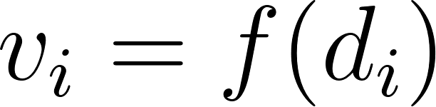
The candidate pool C is the deduplicated union of all per-sub-query retrieval results:
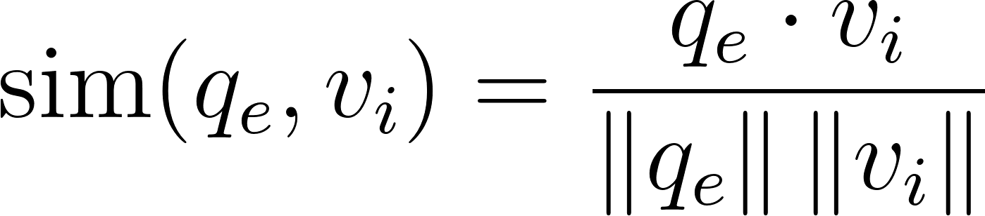
Candidates are retrieved per sub-query and merged; the unified candidate pool  is retained after deduplication across all sub-queries:
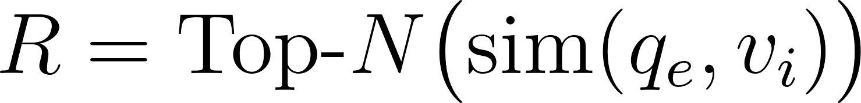
This multi-query retrieval corresponds to the expanded initial retrieval stage in the system retriever
Step 4: Document Embedding Matrix
Construct the embedding matrix of the retrieved documents:

where  represents the embedding of document 
Step 5: Automatic Cluster Number Selection
To determine the optimal number of clusters, KMeans clustering is performed for:
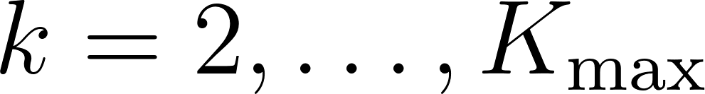
For each clustering configuration:
The optimal number of clusters is determined using the silhouette score:
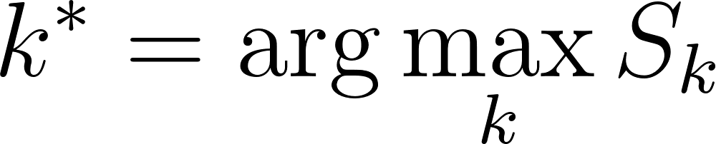
where  is the average silhouette score.
Step 6: Final KMeans Clustering
KMeans clustering is applied using the optimal cluster number:
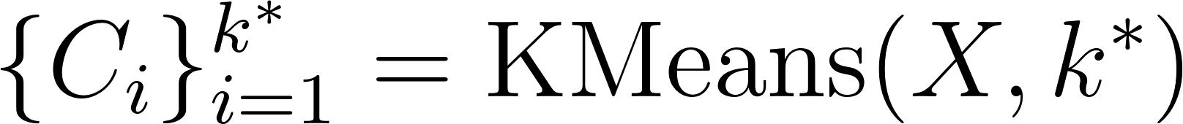
Each cluster groups semantically similar retrieved documents.
Step 7: Energy-Based Cluster Scoring
For each cluster , the energy distance is computed between the query distribution X = {f(qₘ) | qₘ ∈ Q} (all sub-query embeddings) and the cluster document distribution
Let
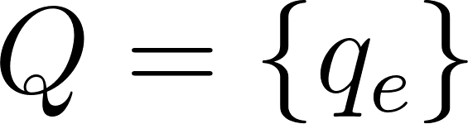
And
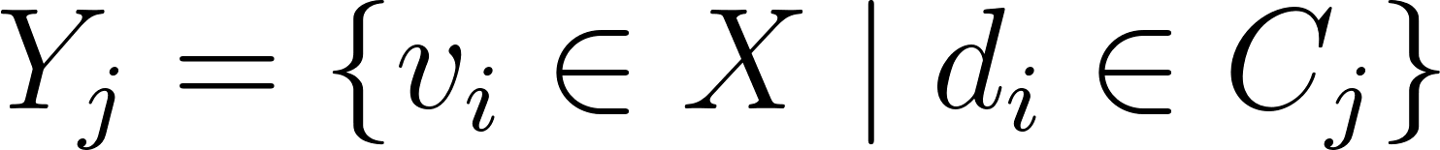
where 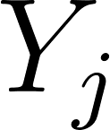 represents the embeddings of documents in cluster ​.
Energy distance is defined as:
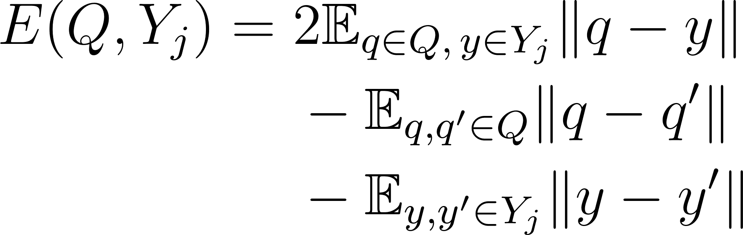
In practice, the energy distance is clipped to be non-negative.
Step 8: Cluster Selection
The cluster with the minimum energy distance to the query is selected:
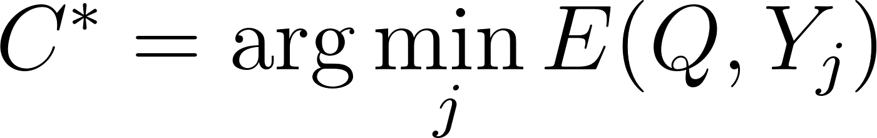
Optionally, the top-K clusters with the lowest energy values can be selected.
The corresponding document set is:
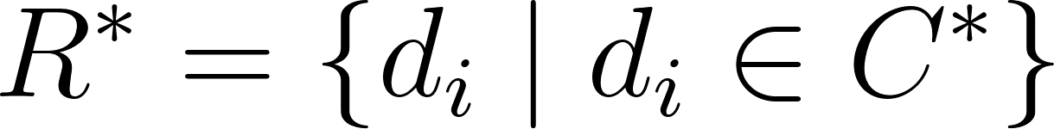
Step 9: LLM-based Document Relevance Filtering
Documents in the selected cluster are evaluated by a Large Language Model (LLM) to determine whether they contain information relevant to the query.
The filtered document set is:
Step 10: Response Generation
The filtered documents are used as context in a Retrieval-Augmented Generation framework:
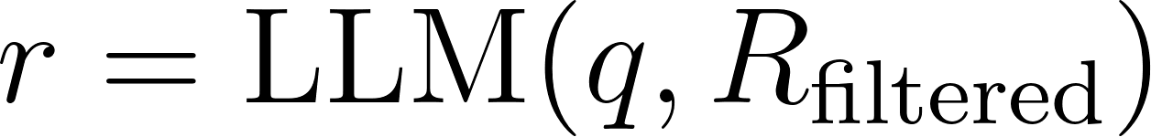

Energy Distance and Clustering Methods
Energy distance has been extensively studied as a statistical measure for comparing probability distributions. Unlike cosine similarity, which evaluates pairwise angular similarity between vectors, energy distance captures distribution-level discrepancies by aggregating pairwise distances across samples (Székely & Rizzo, 2013; Rizzo & Székely, 2016). This property makes it particularly suitable for comparing sets of embeddings rather than individual representations.
Prior research has explored the integration of energy distance into clustering algorithms. Notably, the k-groups method generalizes k-means clustering by replacing the centroid-based objective with an energy distance formulation, enabling clustering over arbitrary distributions instead of relying on Euclidean means (Li & Rizzo, 2017). This approach demonstrates that energy distance can serve as a principled alternative to traditional distance metrics in clustering, especially in high-dimensional spaces.
In natural language processing, energy-based methods have also been applied to ranking and compatibility modeling tasks. For example, Bhattacharyya et al. (2021) proposed an energy-based reranking approach for neural machine translation, where energy functions approximate task-specific evaluation metrics. More recently, Cai et al. (2025) introduced Entriever, an energy-based retriever that models query-document compatibility through an energy function, achieving strong performance in knowledge-grounded dialogue systems. Similarly, Shankar et al. (2025) explored energy-based modeling in retrieval-augmented generation (RAG) to improve reliability and uncertainty estimation.
Despite these advances, existing work primarily employs energy-based methods for clustering objectives, document-level reranking, or confidence estimation, rather than for ranking clusters based on their distributional similarity to a query, which remains underexplored.
Clustering for Retrieval-Augmented Generation
Clustering has emerged as an effective strategy for improving retrieval quality and context efficiency in Retrieval-Augmented Generation (RAG) systems. By grouping semantically similar documents, clustering can reduce redundancy, improve diversity, and mitigate context overflow when interacting with large language models.
Recent studies have proposed clustering-based retrieval frameworks to enhance RAG performance. Several works organize retrieved documents into semantic clusters to compress context and improve downstream LLM reasoning by presenting only the most representative information from each cluster. Other methods dynamically determine retrieval cutoffs by analyzing similarity transitions across document clusters, enabling more efficient context selection and reducing computational overhead. Query-aware clustering approaches further exploit semantic grouping to support multi-stage reasoning and improve retrieval robustness under complex, multi-faceted questions.
While these methods demonstrate the effectiveness of clustering in retrieval pipelines, they typically rely on document-level similarity scores (e.g., cosine similarity) or heuristic aggregation strategies. They do not explicitly model the distributional relationship between a query and an entire cluster, limiting their ability to capture higher-order semantic structure within retrieved documents.

Reranking and Retrieval Optimization in RAG
Reranking is a key component in modern retrieval systems, aiming to refine the ordering of candidate documents after an initial retrieval stage. Traditional approaches rely on cross-encoder architectures that jointly encode query-document pairs to produce relevance scores (Nogueira & Cho, 2019). More recent work has explored hybrid retrieval strategies that combine dense and sparse representations (Chen & Wiseman, 2023; Sawarkar et al., 2024), as well as LLM-based reranking methods that leverage the semantic reasoning capabilities of large language models as re-ranking agents (Sun et al., 2023).
In the context of RAG, reranking is often used to improve the quality of retrieved contexts before generation. However, most existing reranking approaches operate at the individual document level, treating each candidate independently. This design overlooks the structural relationships among retrieved documents and fails to exploit potential benefits of grouping semantically related information.

Research Gap
In summary, prior work has investigated:
- energy distance for clustering and compatibility modeling,
- clustering for improving retrieval efficiency and context organization,
- and reranking techniques for refining document relevance in RAG systems.
However, there is a lack of approaches that integrate these directions to perform:
distribution-level cluster ranking using energy distance within a RAG framework
Existing energy-based methods focus on document-level scoring, while clustering-based retrieval methods rely on heuristic or similarity-based aggregation. The combination of energy distance with clustering for query-aware cluster selection remains largely unexplored.
This gap motivates the proposed approach, which introduces an energy-based mechanism to evaluate the relevance of clusters as distributions, enabling a more expressive and structured retrieval process for RAG systems.

The proposed ERC-RAG algorithm integrates seamlessly with the Vietnamese Economy Information Database (VEID), ensuring domain-specific retrieval through semantic KMeans clustering and distributional energy-based scoring tailored for economic question answering.
- Experimental Protocol
We employ the Vietnamese Economy Information Database (VEID), released in 2024 and introduced in prior studies (Ngo-Ho et al., 2024a; Ngo-Ho et al., 2024b). To the best of our knowledge, VEID is the first database specifically designed for evaluating chatbot systems in the Vietnamese economic domain. In Ngo-Ho et al. (2025), the authors presented a benchmark dataset consisting of 1,000 question-answer pairs automatically generated from VEID. In this work, we adopt this benchmark dataset for our experiments.
Our experiments follow the same protocol as those reported in prior studies (Ngo-Ho et al., 2024a; Ngo-Ho et al., 2024b; Ngo-Ho et al., 2025), enabling direct performance comparisons across different model configurations. To evaluate the retrieval performance of ERC-RAG, we verify whether the top-1 document returned by the selected energy-minimal cluster contains the correct answer to the user query.
To assess the quality of the generated answers, we evaluate two retrieval configurations: the Energy-based Reranking RAG baseline, tested with three API-based LLMs (Grok-4-1-fast-reasoning, Gemini-2.5-flash-lite, and GPT-4o-mini), and the proposed ERC-RAG, evaluated with GPT-5.0-mini. This setup enables direct ablation between the document-level reranking approach and the distribution-aware cluster selection approach introduced in this paper. To facilitate comparison with prior RAG baselines, we reuse the experimental results reported in Ngo-Ho et al. (2025), in which the authors conducted a comparative evaluation of four LLMs including GPT-4o-mini, VinaLLaMA (Nguyen et al., 2023), Vistral (Chien Van Nguyen et al., 2023), and OpenChat-3.5 (Wang et al., 2023).
The experimental implementation uses the following configuration. All document chunks are generated using RecursiveCharacterTextSplitter with a chunk size of 600 characters and a chunk overlap of 80 characters, yielding 120,165 indexed vectors stored in a ChromaDB persistent vector store. Text encoding is performed using the intfloat/multilingual-e5-base model (768 dimensions, L2-normalized), with the E5 prefix protocol applied automatically: the prefix 'query: ' is prepended to query texts and 'passage: ' to document texts. During retrieval, up to 40 candidate documents are retrieved per sub-query via cosine similarity. KMeans clustering is then applied to the candidate document vectors with the number of clusters k ∈ {2, …, min(10, |C|−1)}, where |C| denotes the number of candidates; the optimal k is selected by maximizing the silhouette score (random_state=42, n_init='auto'). Document grading is performed via a single batched LLM call in which all candidate documents from the selected cluster are presented together and the model returns a JSON array of relevant document indices. The same LLM instance is used for query decomposition, batch document grading, and answer generation.
For evaluation, we employ multiple complementary metrics to assess the quality of generated responses. ROUGE scores are used to quantify n-gram overlap between generated outputs and reference answers. Specifically, ROUGE Recall measures the extent to which reference content is covered, ROUGE Precision evaluates the proportion of generated content that is relevant, and ROUGE F1 provides a balanced assessment by combining precision and recall. In addition, BLEU is adopted to evaluate surface-level fluency and lexical similarity by computing n-gram overlap with a brevity penalty, reflecting how closely the generated responses align with the reference texts in terms of phrasing and structure (Papineni et al., 2002). Notably, Ngo-Ho et al. (2025) report only BLEU.
- Results and Discussion
Regarding retrieval performance, when using cosine similarity alone, the chatbot correctly identifies the top-relevant document for 42.3% of the question-answer pairs. By incorporating ERC-RAG, this accuracy increases to 51.2%. Additionally, ERC-RAG achieves a Mean Reciprocal Rank (MRR) of 0.62, Hit@5 of 0.64, and NDCG@5 of 0.83 on the VEID benchmark. These retrieval metrics collectively indicate that the energy-based cluster selection mechanism effectively surfaces relevant documents within the top-5 retrieved results, with a high degree of ranking quality as measured by NDCG@5.
Table 1 presents a detailed comparison between the proposed ERC-RAG (with GPT-5.0-mini), the Energy-based Reranking RAG baseline (with three LLMs), and conventional RAG baselines on the VEID dataset, using ROUGE-2 metrics (Recall, Precision, F1), BLEU-2 scores, Cosine Similarity, Mean Reciprocal Rank (MRR), Hit@5, and NDCG@5. Baseline RAG models (paired with VinaLLaMA-7B-chat, Vistral-7B-chat, Openchat-3.5-7B, GPT-3.5-turbo, or GPT-4o-mini) report only BLEU-2 scores, ranging from 0.21 to 0.46, limiting a full assessment of answer quality (Ngo-Ho et al., 2025). The Energy-based Reranking RAG baseline provides additional ROUGE-2 metrics across three LLMs, while ERC-RAG further reports Cosine Similarity, MRR, Hit@5, and NDCG@5, offering the most comprehensive evaluation.
Table 1. Performance comparison of ERC-RAG, Energy-based Reranking RAG baseline, and conventional RAG models on ROUGE-2 Recall, ROUGE-2 Precision, ROUGE-2 F1, BLEU-2, Cosine Similarity, MRR, Hit@5, and NDCG@5 on the VEID dataset.

Algorithm | BLEU-2 | ROUGE-2  Recall | ROUGE-2  Precision | ROUGE-2  F1 | Cosine  Similarity | Mean Reciprocal  Rank | Hit@5 | NDCG@5 | Source
RAG + VinaLLaMA-7B-chat | 0.26 | - | - | - | - | - | - | - | (Ngo-Ho et al., 2025)
RAG + Vistral-7B-chat | 0.23 | - | - | - | - | - | - | - | (Ngo-Ho et al., 2025)
RAG + Openchat-3.5-7B | 0.21 | - | - | - | - | - | - | - | (Ngo-Ho et al., 2025)
RAG + GPT-3.5-turbo | 0.46 | - | - | - | - | - | - | - | (Ngo-Ho et al., 2025)
RAG + GPT-4o-mini | 0.33 | - | - | - | - | - | - | - | (Ngo-Ho et al., 2025)
Energy-based Reranking RAG + Grok-4-1-fast-reasoning | 0.34 | 0.32 | 0.59 | 0.22 | - | - | - | - | Internal ablation
Energy-based Reranking RAG + Gemini-2.5-flash-lite | 0.52 | 0.5 | 0.69 | 0.4 | - | - | - | - | Internal ablation
Energy-based Reranking RAG + GPT-4o-mini | 0.61 | 0.57 | 0.74 | 0.49 | - | - | - | - | Internal ablation
ERC-RAG + GPT-5.0-mini | 0.65 | 0.68 | 0.70 | 0.68 | 0.95 | 0.62 | 0.64 | 0.83 | Proposed method

Among the Energy-based Reranking RAG configurations (rows 6–8), ROUGE-2 Precision ranges from 0.59 (Grok-4-1-fast-reasoning) to 0.74 (GPT-4o-mini), and BLEU-2 reaches 0.61 with GPT-4o-mini, indicating that document-level energy reranking already improves answer focus compared to vanilla RAG baselines (BLEU-2 up to 0.46). The proposed ERC-RAG framework with GPT-5.0-mini (row 9) achieves ROUGE-2 F1 = 0.68, ROUGE-2 Recall = 0.68, ROUGE-2 Precision = 0.70, and BLEU-2 = 0.65, representing substantial improvements over the best Energy-based Reranking RAG configuration (ROUGE-2 F1: +0.19, BLEU-2: +0.04). The improved F1 score reflects a better balance between coverage and precision achieved by the distribution-aware cluster selection mechanism, which considers the full semantic structure of the query rather than individual similarity scores.
ERC-RAG also reports retrieval-level metrics not available for the baseline approaches. A Cosine Similarity of 0.95 confirms strong semantic alignment between the selected cluster and the query distribution. The MRR of 0.62 and Hit@5 of 0.64 indicate that the correct document appears within the top-5 results in approximately 64% of cases, with an NDCG@5 of 0.83 reflecting high ranking quality. These retrieval metrics collectively demonstrate that LLM-based query decomposition, combined with energy-based cluster selection, produces a well-ranked candidate set that supports high-quality answer generation. Notably, even the lower-scoring LLM configuration (Grok-4-1-fast-reasoning, BLEU-2=0.34) benefits from the reranking mechanism, suggesting that retrieval quality gains are somewhat independent of the generation model's inherent reasoning capability.
Overall, ERC-RAG delivers the best performance across all reported metrics, with ROUGE-2 F1 = 0.68, BLEU-2 = 0.65, MRR = 0.62, Hit@5 = 0.64, and NDCG@5 = 0.83. These results demonstrate that the combination of LLM query decomposition, semantic KMeans clustering, and energy-based distribution matching is a robust strategy for enhancing both retrieval and generation quality in domain-specific RAG systems, particularly for tasks requiring precise, factually grounded responses in the Vietnamese economic domain.
- Conclusion
This paper presented the Energy-based Retrieval Clustering RAG (ERC-RAG) framework for domain-specific Vietnamese economy chatbots. Motivated by the limitations of cosine similarity in capturing complex query-document compatibility and the insufficiency of single-vector query representations, we proposed a three-stage architecture: LLM-based query decomposition to form a query distribution, cosine-based multi-query candidate retrieval, and energy distance scoring between the query distribution and each KMeans document cluster. By selecting the cluster with the minimum energy distance as the context for generation, ERC-RAG enables a more expressive and distribution-aware retrieval mechanism than conventional single-query similarity-based approaches.
From a broader perspective, this work contributes to the emerging line of research exploring energy-based models in retrieval-augmented generation. Unlike prior studies that primarily employ energy functions for confidence estimation, document-level reranking, or abstention, our approach operationalizes energy distance between distributions as the core cluster selection signal within a practical RAG pipeline. The integration of LLM-based query decomposition with distributional energy scoring represents an under-investigated combination in the context of domain-specific Vietnamese economic chatbots. Future work will explore hybrid training objectives, integration with human feedback, and efficiency optimizations to further balance retrieval accuracy, response quality, and computational cost in real-world deployments.
References
- Ait-Mlouk, A., & Jiang, L. (2020). KBot: a Knowledge graph based chatBot for natural language understanding over linked data. IEEE Access, 8, 149220-149230.
- Chien Van Nguyen, Thuat Nguyen, Quan Nguyen, Huy Nguyen, Björn Plüster, Nam Pham, Huu Nguyen, Patrick Schramowski, Thien Nguyen. “Vistral-7B-Chat - Towards a State-of-the-Art Large Language Model for Vietnamese”. 2023.
- Gutmann, M., & Hyvärinen, A. (2010). Noise-contrastive estimation: A new estimation principle for unnormalized statistical models. Proceedings of the Thirteenth International Conference on Artificial Intelligence and Statistics (AISTATS).
- Kayal, S. (2021, April). Unsupervised sentence-embeddings by manifold approximation and projection. In Proceedings of the 16th Conference of the European Chapter of the Association for Computational Linguistics: Main Volume (pp. 1-11).
- Ngo-Ho, A.-K., Vo, K.-D., & Ngo-Ho, A.-K. (2024c). VQABG: Vietnamese question/answers benchmark generator for field-specific chatbot ground-truth dataset using EMINI (Exact Match wIth Numeric Information) indicator. CTU Journal of Innovation and Sustainable Development , 16(Special issue: ISDS), 80-90. https://doi.org/10.22144/ctujoisd.2024.325
- Ngo-Ho, AK., Vo, KD., Ngo-Ho, AK. (2025). Evaluation of Large Language Models for the Vietnamese Language in Generative Vietnamese Economy Chatbots (GVEC) Services. In: Yeom, S. (eds) 6th International Conference on Electronics and Signal Processing. ICESP 2024. Signals and Communication Technology. Springer, Cham. https://doi.org/10.1007/978-3-031-94973-9_19
- Ngo-Ho A.-Khoi., Ngo-Ho A.-Khoa, Vo K.-D. (2024a). GVEC: A Vietnamese Large Language Models Chatbot For Economy, Using Vietnamese Economy Information Database (VEID) From Vneconomy Community. The 7th International Conference on Multimedia Analysis and Pattern Recognition (MAPR 2024), Hanoi, Vietnam.
- Ngo-Ho A.-Khoi., Ngo-Ho A.-Khoa, Vo K.-D. (2024b). GVEC: Generative Vietnamese Economy Chatbots using Vietnamese Numeric Economy Information Question/Answer Dataset (VNEIQAD) benchmark. The 17th International Conference on Advanced Technologies for Communications (ATC 2024), Hanoi, Vietnam.
- Nguyen, Quan, Huy Pham, and Dung Dao. “VinaLLaMA: LLaMA-based Vietnamese Foundation Model”. arXiv preprint arXiv:2312.11011, 2023.
- Ni, P., Okhrati, R., Guan, S., & Chang, V. (2024). Knowledge graph and deep learning-based text-to-GraphQL model for intelligent medical consultation chatbot. Information Systems Frontiers, 26(1), 137-156.
- Papineni, K., et al. (2002). Bleu: a method for automatic evaluation of machine translation. Proceedings of the 40th AMACL.
- Rackauckas, Z. (2024). Rag-fusion: a new take on retrieval-augmented generation. arXiv preprint arXiv:2402.03367.
- Sawarkar, K., Mangal, A., & Solanki, S. R. (2024). Blended rag: Improving rag (retriever-augmented generation) accuracy with semantic search and hybrid query-based retrievers. In 2024 IEEE 7th international conference on multimedia information processing and retrieval (MIPR) (pp. 155-161). IEEE.
- Wang, Guan, et al. “Openchat: Advancing open-source language models with mixed-quality data”. arXiv preprint arXiv:2309.11235, 2023.
- Ye, X., Iyer, S., Celikyilmaz, A., Stoyanov, V., Durrett, G., & Pasunuru, R. (2023, July). Complementary explanations for effective in-context learning. In Findings of the Association for Computational Linguistics: ACL 2023 (pp. 4469-4484).
- Bhattacharyya, S., Rooshenas, A., Naskar, S., Sun, S., Iyyer, M., & McCallum, A. (2021). Energy-based reranking: Improving neural machine translation using energy-based models. In Proceedings of the 59th Annual Meeting of the Association for Computational Linguistics ACL 2021, (pp. 4528–4537). Association for Computational Linguistics. https://aclanthology.org/2021.acl-long.349
- Cai, Y., Li, K., Huang, Y., Feng, J., & Ou, Z. (2025). Entriever: Energy-based retriever for knowledge-grounded dialog systems. In Findings of the Association for Computational Linguistics: ACL 2025 (pp. 21462–21474). Association for Computational Linguistics. https://aclanthology.org/2025.findings-acl.1105
- Li, S., & Rizzo, M. L. (2017). K-groups: A Generalization of K-means Clustering. arXiv preprint arXiv:1711.04359. https://arxiv.org/abs/1711.04359
- Chen, X., & Wiseman, S. (2023). BM25 query augmentation learned end-to-end. arXiv preprint arXiv:2305.14087. https://arxiv.org/abs/2305.14087
- Khattab, O., & Zaharia, M. (2020). ColBERT: Efficient and Effective Passage Search via Contextualized Late Interaction over BERT. In Proceedings of the 43rd International ACM SIGIR Conference on Research and Development in Information Retrieval. https://arxiv.org/abs/2004.12832
- LeCun, Y., Chopra, S., Hadsell, R., Ranzato, M., & Huang, F. (2006). A tutorial on energy-based learning. In G. Bakir, T. Hofmann, B. Schölkopf, A. Smola, B. Taskar, & S. V. N. Vishwanathan (Eds.), Predicting structured data (pp. 1–59). MIT Press. https://web.stanford.edu/class/cs379c/archive/2012/suggested_reading_list/documents/LeCunetal06.pdf
- Nogueira, R., & Cho, K. (2019). Passage re-ranking with BERT. arXiv preprint arXiv:1901.04085. https://arxiv.org/abs/1901.04085
- Rizzo, M. L., & Székely, G. J. (2016). Energy distance. Wiley Interdisciplinary Reviews: Computational Statistics, 8(1), 27–38. https://doi.org/10.1002/wics.1375
- Shankar, R., Wong, S., Li, L., Bachmann, M., Silverthorne, A., Albert, B., & Jones, G. (2025). Energy landscapes enable reliable abstention in retrieval-augmented large language models for healthcare. arXiv preprint arXiv:2509.04482. https://arxiv.org/abs/2509.04482
- Székely, G. J., & Rizzo, M. L. (2013). Energy statistics: A class of statistics based on distances. Journal of Statistical Planning and Inference, 143(8), 1249–1272. https://doi.org/10.1016/j.jspi.2013.03.018
- Wang, L., Yang, N., Huang, X., Jiao, B., Yang, L., Jiang, D., Majumder, R., & Wei, F. (2022). Text embeddings by weakly-supervised contrastive pre-training. arXiv preprint arXiv:2212.03533. https://arxiv.org/abs/2212.03533
- Sun, W., Yan, L., Ma, X.,Wang, S., Ren, P., Chen, Z., Yin, D., & Ren, Z. (2023). Is ChatGPT good at search? Investigating large language models as re-ranking agents. arXiv preprint arXiv:2304.09542. https://arxiv.org/abs/2304.09542
- Asai, A., Wu, Z., Wang, Y., Sil, A., & Hajishirzi, H. (2023). Self-RAG: Learning to retrieve, generate, and critique through self-reflection. arXiv preprint arXiv:2310.11511. https://arxiv.org/abs/2310.11511

